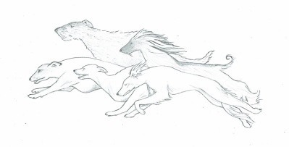
QUEENSLAND SIGHTHOUND ASSOCIATION

APPLICATION FOR MEMBERSHIP

Send applications to Please Tick applicable box
Queensland Sighthound Association RENEWAL
36-42 Pennine Dr
Nth Maclean. QLD 4280 NEW
qsa.enquiry@hotmail.com

Title: ................ Surname: .......................................... Given Name: ..........................................

(CCC(Q) or Affiliated Organisation Membership No.) __________________________

Title: ................ Surname: .......................................... Given Name: ..........................................

(CCC(Q) or Affiliated Organisation Membership No.) __________________________

Address: ........................................................ Suburb: .......................................... Post Code: ............

Phone: (home) .................................... (mobile) .......................................

Email: ....................................................................................................................................................
(Please print clearly)

PLEASE NOTE JOINT MEMBERSHIPS ARE ONLY APPLICABLE FOR THE SAME RESIDENTIAL ADDRESS

MEMBERSHIP CATEGORY DESIRED:
SINGLE  $15.00 | JOINT  $25.00
(Please circle which is applicable)

Breeds Owned.......................................................................................................................................

I/We hereby apply for membership of the Queensland Sighthound Association and certify that the information contained in the form above is true and correct and that I/We have read the Rules and the Code of Ethics of the QSA and that I/We agree to be bound by them for the duration of my/our membership. I/We further certify that we are not disqualified or suspended members of any other Canine Controlling body, nor are there any outstanding matters of any kind between myself/us and any other Canine Controlling body. I/We acknowledge that by signing this form I am/we are over 18 years of age.

SIGNATURE(S) (1) ....................................................... (2) .....................................................................................
IF APPLYING FOR JOINT MEMBERSHIP BOTH PARTIES MUST SIGN

OFFICE USE ONLY

Date received: .................................................... Receipt no: .......................................................... SM ......... JM ............

Membership No: ................................................

